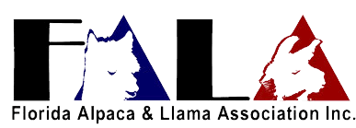
Membership Renewal Form
Name (s) ________________________________________________________
Farm Name: ________________________________________________________
Street or PO Box: ___________________________________________________
City or Town: ________________State _____ County ____________Zip ________
Telephone: Home: _________________ Cell:______________________________
Email: _________________________________________
Website: _______________________________________
Number of Alpacas _____________ Number of Llamas _________________
Farm available for farm visits Yes ____ No ____
Dues:
Lifetime Membership $500.00 _________
Annual Family/Farm/ Veterinarian $25.00 _________
Non-Voting Member/Youth $7.00 ________
Please Remit Payment to:
FALA
Mary Rose Collins
4211 S. Old Floral City Rd.
Inverness, FL 34450

Membership is due by January 31

